Sudan

## Population Data

The data set shows the political stability estimate of the country each year.

## # A tibble: 23 x 5  
## country iso3c date population popCategory5  
## <chr> <chr> <dbl> <dbl> <chr>   
## 1 Sudan SDN 1996 24782383 small   
## 2 Sudan SDN 1997 25413917 medium   
## 3 Sudan SDN 1998 26015521 medium   
## 4 Sudan SDN 1999 26626520 medium   
## 5 Sudan SDN 2000 27275015 medium   
## 6 Sudan SDN 2001 27971082 medium   
## 7 Sudan SDN 2002 28704778 medium   
## 8 Sudan SDN 2003 29460519 medium   
## 9 Sudan SDN 2004 30214193 medium   
## 10 Sudan SDN 2005 30949516 medium   
## 11 Sudan SDN 2006 31661823 medium   
## 12 Sudan SDN 2007 32360621 medium   
## 13 Sudan SDN 2008 33060837 medium   
## 14 Sudan SDN 2009 33783788 medium   
## 15 Sudan SDN 2010 34545013 medium   
## 16 Sudan SDN 2011 35349681 medium   
## 17 Sudan SDN 2012 36193783 medium   
## 18 Sudan SDN 2013 37072550 medium   
## 19 Sudan SDN 2014 37977655 medium   
## 20 Sudan SDN 2015 38902950 medium   
## 21 Sudan SDN 2016 39847440 medium   
## 22 Sudan SDN 2017 40813396 medium   
## 23 Sudan SDN 2018 41801533 medium

# Population growth data

## # A tibble: 23 x 5  
## country iso3c date popGrowth popGrowthCat5   
## <chr> <chr> <dbl> <dbl> <chr>   
## 1 Sudan SDN 1996 2.81 high growth rate   
## 2 Sudan SDN 1997 2.52 high growth rate   
## 3 Sudan SDN 1998 2.34 moderate growth rate  
## 4 Sudan SDN 1999 2.32 moderate growth rate  
## 5 Sudan SDN 2000 2.41 moderate growth rate  
## 6 Sudan SDN 2001 2.52 high growth rate   
## 7 Sudan SDN 2002 2.59 high growth rate   
## 8 Sudan SDN 2003 2.60 high growth rate   
## 9 Sudan SDN 2004 2.53 high growth rate   
## 10 Sudan SDN 2005 2.40 moderate growth rate  
## 11 Sudan SDN 2006 2.28 moderate growth rate  
## 12 Sudan SDN 2007 2.18 moderate growth rate  
## 13 Sudan SDN 2008 2.14 moderate growth rate  
## 14 Sudan SDN 2009 2.16 moderate growth rate  
## 15 Sudan SDN 2010 2.23 moderate growth rate  
## 16 Sudan SDN 2011 2.30 moderate growth rate  
## 17 Sudan SDN 2012 2.36 moderate growth rate  
## 18 Sudan SDN 2013 2.40 moderate growth rate  
## 19 Sudan SDN 2014 2.41 moderate growth rate  
## 20 Sudan SDN 2015 2.41 moderate growth rate  
## 21 Sudan SDN 2016 2.40 moderate growth rate  
## 22 Sudan SDN 2017 2.40 moderate growth rate  
## 23 Sudan SDN 2018 2.39 moderate growth rate

## Population trend

The plot shows the population trend of the country.

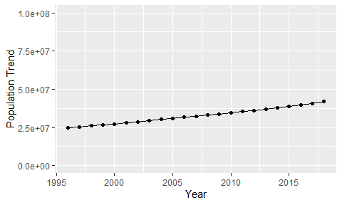

Political Stability Trend

# Population growth trend

The plot shows the population growth rate trend of the country.

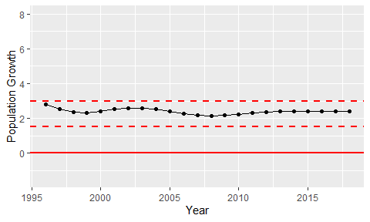

Population Growth Trend